STATE OF GEORGIA
COUNTY OF WASHINGTON
INTERGOVERNMENTAL AGREEMENT FOR MAINTENANCE
This intergovernmental agreement (hereinafter “Agreement” or “IGA”) is made and entered into on the ___ day of August, 2026, by and between WASHINGTON COUNTY, GEORGIA, a political subdivision of the State of Georgia, acting by and through its governing authority, the WASHINGTON COUNTY BOARD OF COMMISSIONERS (hereinafter “the County”), and the MAYOR AND CITY COUNCIL OF SANDERSVILLE, GEORGIA (hereinafter “City” or “Sandersville”).
WHEREAS, the County currently owns and is responsible for routine maintenance, paving, patching, sweeping, mowing, storm drainage upkeep, striping, and major capital improvements to or resurfacing for that certain section of right-of-way known as Highway 24E/East McCarty St. from the Sandersville City Limits (just east of Franklin Haynes Dr.) to the intersection of said road with Ridge Road (now also known as the Truck Route on the east side of Sandersville from SR 242 to SR 15) covering an approximate distance of 8/10 of a mile (hereinafter “East McCarty St. Segment” with a highlighted map for the purposes of further identification attached as Exhibit “A”); and
WHEREAS, the City has applied for a OneGeorgia Rural Workforce Housing Initiative infrastructure grant (hereinafter “Workforce Grant”) with the State of Georgia OneGeorgia Authority (hereinafter “OneGeorgia”) to help fund the construction of public infrastructure to support the residential housing development with SDH Central Georgia LLC, a Georgia Limited Liability Company and an affiliate of Smith Douglas Homes (hereinafter “Developer”); and
WHEREAS, the Developer intends to develop said residential neighborhood consisting of approximately sixty-eight (68) owner-occupied single-family homes (hereinafter “the Development”) on Washington County Tax Map and Parcel 110 033 which consists of approximately 26.25 acres that lies on the north side of the East McCarty St. Segment that is the subject of this IGA (hereinafter “the Property” and further described in the legal description that is attached hereto as Exhibit “B”); and
WHEREAS, the City and County have agreed to annex the Property into the City in accordance with Georgia Law, with the qualification that the Property will be de-annexed should the City not be awarded the Workforce Grant; and
WHEREAS, as a condition of said annexation, and due to the likely increase in vehicle traffic on the East McCarty St. Segment as a result of the annexation and Development, the County desires that the City agree to provide the routine maintenance for the East McCarty Segment as part of the County’s agreement to the annexation of said Property; and
WHEREAS, upon annexation and upon approve of the Workforce Grant, the City will agree to be responsible for routine maintenance, paving, patching, sweeping, mowing, storm drainage upkeep, striping, and major capital improvements to or resurfacing for the East McCarty St. Segment that is the subject of this IGA as further defined in this Agreement; and
WHEREAS, the Parties do not intend to change the ownership of the East McCarty St. Segment by this Agreement but the Parties may agree to such change at a future date by mutual agreement in writing or otherwise in accordance with Georgia law; and
WHEREAS, this Agreement is contingent upon the City being awarded the Workforce Grant as described herein that was applied for in July of 2026; and
WHEREAS, the Parties desire to formalize their understanding concerning the routine maintenance, paving, patching, sweeping, mowing, storm drainage upkeep, striping, signage and major capital improvements to or resurfacing for the East McCarty St. Segment that is the subject of this IGA as further defined in this Agreement; and
WHEREAS, Sandersville and the County are authorized to enter into this Agreement pursuant to the provisions of Article IX, Section III, Paragraph I of the Constitution of the State of Georgia provided this agreement does not exceed 50 years; and
WHEREAS, the Constitution of the State of Georgia provides, in Article IX, Section II, Paragraph III, that a city may exercise certain specified supplementary powers, including, but not limited to, additional services pertaining to street and road construction and maintenance through a contract with the City and County; and
WHEREAS, pursuant to the Georgia Service Delivery Strategy Law, O.C.G.A 36-70-1 (hereinafter “Service Delivery Law”), the City and County continue to be engaged in the development and implementation of a service delivery system that is both efficient and responsive to the citizens of the City and County; and
WHEREAS, both Parties believe that it would be in the interest of the health, safety and welfare of the citizens of the City and County to enter this Agreement; and
NOW THEREFORE, in consideration of the mutual promises, covenants, and obligations contained herein, the Parties hereto agree as follows:
1. The City applied for the Workforce Grant in July of 2026 and is waiting to hear from OneGeorgia as to whether that Workforce Grant will be awarded to the City.
2. If the Workforce Grant is awarded to the City and the Developer starts the Development on the Property, the City agrees to be responsible, both financially and for labor, for any and all routine maintenance, paving, patching, sweeping, mowing, storm drainage upkeep, striping, and major capital improvements to and/or milling and resurfacing for the East McCarty St. Segment as further defined in this Agreement and shown on the attached Exhibit “A”.
3. In return for the City’s acceptance of the responsibility of maintenance as further described in paragraph 2 herein, for the term of this Agreement and to the extent permitted by Georgia law, the City and County agree that the East McCarty St. Segment will be counted towards the City’s total linear road miles for the purposes of calculating the annual road repair allocations in connection with Local Maintenance & Improvement Grant (LMIG) funds, Local Road Assistance (LRA) funds, and any other similar funds from the Georgia Department of Transportation (GDOT) and the State of Georgia; the City and County agree to notify GDOT or other appropriate authority as required by law in order to keep up-to-date records of the City and County road systems.
4. This Agreement is contingent upon the City being awarded the Workforce Housing Grant as contemplated by this Agreement; further and per the County’s request, the City agrees to de-annex the Property should the Workforce Housing Grant not be awarded to the City and the Developer not develop the Development; and as a result and if said contingencies are not realized, the Parties agree to mutually terminate this Agreement in writing.
5. Otherwise, the term of this Agreement shall be ten (10) years, said term commencing on January 1, 2027 and ending on December 31, 2036. The City and County agree that this Agreement with automatically renew for one (1) successive ten (10) year term unless both sides elects to terminate this Agreement by mutual consent at least sixty (60) days prior to the end of any ten (10) year term; in any event, the Agreement will terminate after the two ten (10) year terms and the maintenance responsibility described herein will revert to the County’s responsibility so long as the condition of the East McCarty St. Segment is in substantially the same condition as it exists on the date of the signing of this Agreement, or unless otherwise agreed to in writing; furthermore, as to the current condition of the East McCarty St. Segment, the City and the County hereby acknowledge that the East McCarty St. Segment was milled and resurfaced in 2026 and each party desires that the East McCarty St. Segment shall be in a similar condition at the end of the term of this Agreement; the City and County may modify the conditions of this Agreement when mutually acceptable to both Parties and in writing, including but not limited to necessary adjustments in fees, services and duration provided the term never exceeds 50 years cumulative. The Parties agree to otherwise negotiate in good faith as to the future maintenance of the East McCarty Street Segment at the end of said term(s).
6. Both Parties agree that the East McCarty Street Segment that is the subject of this
Agreement is attached as Exhibit “A” and the Property is attached as Exhibit “B”.
7. Neither the City nor the County shall indemnify or hold harmless the other party’s agents, inspectors, servants and employees, past and present. Both the City and the County shall assume and defend at their own cost, any suit, action or other legal proceeding brought against it arising therefrom.
8. If a dispute arising out of or relating to this IGA or an alleged breach thereof occurs, the Parties must first attempt to resolve any such dispute amicably and through a meeting of their appointed representatives, which shall occur at an agreed-upon time and place within Washington County, Georgia. A Party may initiate this process by providing written notice to the other party. Neither party shall be deemed to have waived any rights or remedies available under Georgia law by participating in any such meeting.
9. Neither party shall be deemed to be in default of any provision of this Agreement nor liable for any delay, failure of performance, or interruption of performance resulting from acts of war, acts of terrorism, civil disturbance, labor strikes or stoppages, epidemics or pandemics, severe weather events, floods, fires, earthquakes, or other similar force majeure events beyond the reasonable control of a party. If a party claims a force majeure event, it must provide written notice thereof to the other party as soon as reasonably possible.
10. The recitals beginning with “WHEREAS” above provide important context and background for this IGA and are incorporated herein by reference.
11. If one party breaches any of the terms or conditions of this Agreement, the non-breaching party may notify the breaching party of the breach in writing. Such written notice shall describe the breach in sufficient detail to enable the breaching party to take corrective action to cure the breach. If the breaching party fails to cure the breach through corrective action within thirty (30) days of receiving written notice of same, the non-breaching party may, without further notice and without prejudice to any other legal or equitable remedies, terminate this agreement by sending the breaching party written notice of the termination.
12. This Agreement shall be governed by and construed in accordance with the laws of the State of Georgia. Venue shall lie in Washington County, Georgia.
13. Any notices required or permitted to be given under this Agreement shall be in writing and deemed sufficient when sent to the respective Parties at the following addresses:
If to the County: Chris Hutchings, Administrator
Washington County Board of Commissioners
P.O. Box 271
Sandersville, GA 31082

If to Sandersville: Kandice Hartley, City Manager
City of Sandersville
P.O. Box 71
Sandersville, GA 31082

14. This Agreement shall be binding upon and shall inure to the benefit of the successors and assigns of the Parties hereto.
15. This Agreement, including any exhibits attached hereto and incorporated herein by reference, constitutes the entire agreement between the Parties with regard to the subject matter hereof, and any other conditions or representations not contained herein, whether written or oral, shall not be binding on the Parties. This Agreement may only be modified by a written amendment referencing this Agreement and duly executed by the Parties hereto.
16. This Agreement may be executed in counterparts.
IN WITNESS WHEREOF, the Parties have caused this agreement to be executed by their
representative and duly authorized officers on the dates indicated below.

BOARD OF COMMISSIONERS OF
WASHINGTON COUNTY, GEORGIA

By:_________________________________
Mel Daniel, Chairman

Attest:______________________________
Chris Hutchings, Administrator

Date:_______________________________

MAYOR AND CITY COUNCIL OF
SANDERSVILLE, GEORGIA

By:_________________________________
Jimmy Andrews, Mayor

Attest:______________________________
Gloria Waller, City Clerk

Date:_______________________________
EXHIBIT “A”

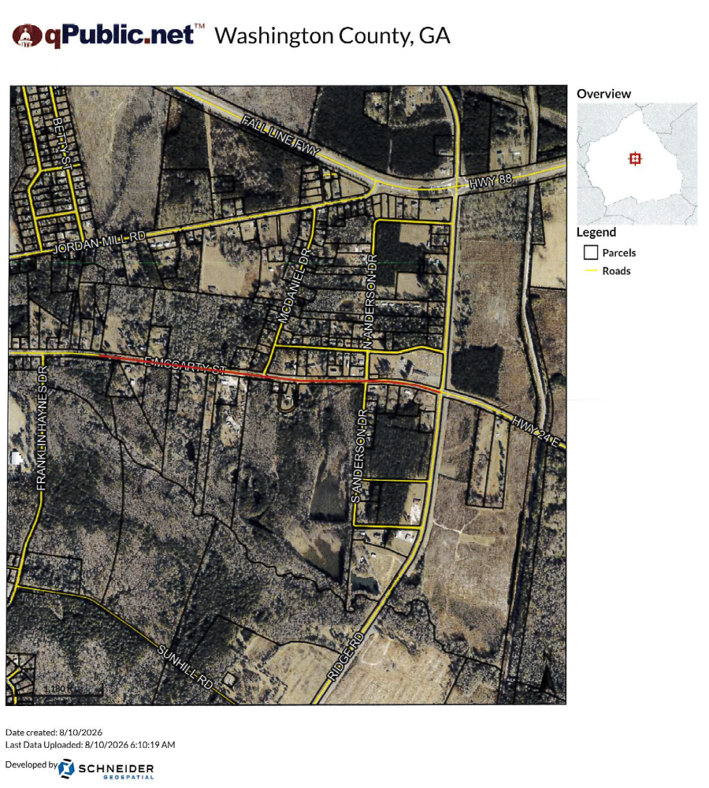

EXHIBIT “B”

All that tract or parcel of land with improvements thereon, situate, lying and being in the 93rd GM District of Washington County, Georgia and containing approximately 26.25 acres, more or less and said tract of land being bound now or formerly as follows: North by property of William Sheppard; East by property of C.B. Wallace and Sunrise Subdivision; South by State Highway 24/Sandersville-Davisboro Highway and property of William F. Murphy; and West by property of William F. Murphy and Paul F. Thiele. The property conveyed was formerly owned by Faye H. Hall and Cecil Hall and is portions of Lots 18 thru 22 on plat of survey recorded in Deed Book JJ, page 2, Washington County Superior Court Records.

This property was incorrectly described in a prior deed recorded in Deed Book 7-K, page 79, Washington County Records, as containing 12 acres, more or less, but the acreage description contained in that deed was incorrect.

Said property is identified as Map and Parcel 110 033 by the Washington County Tax Assessor’s Office.

